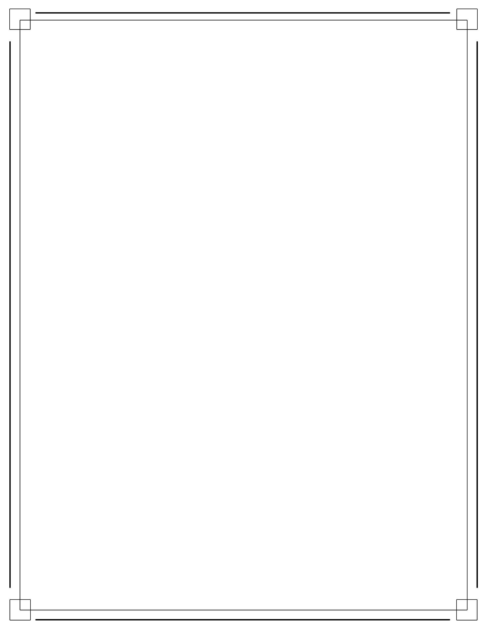University Conference Center System (UCCS)

Executable Release: Compilation/Connection to Cloud SQL

Effective Date: 4/10/15

{Group 2} Systems Engineer

Working-Level Integrated Product Team (WIPT) Executable Release

*Skeleton Construction*

1. Executable Release: Skeleton Construction
2. Goal:
   1. Successful compilation of the system including all of its classes, and external dependencies. Method definitions should contain just enough to compile and implement *no* details.
3. Classes to be Implemented:
   1. Business Registration Form
   2. Guest Registration Form
   3. Record
   4. Registration Form
   5. Schedule
   6. Session
4. Previously Implemented Classes to Use:
   1. N/a
5. Use Case to be Implemented:
   1. N/a
6. Inputs:
   1. User input (Dummy Information)
7. Outputs:
   1. Compilation
8. Release Date:
   1. *4/11/15 12:00 PM*